LOGISTIC REGRESSION – R-SQUARED AND P-VALUE
REVIEW
In the las StatQuest [2] fitting a line with max-likelihood …
… we had WEIGHT measurements for OBESE mice and weight measurements for some mice that were NOT OBESE… and we converted the y-axis from probability to the log(odds of obesity) … and then fit line to that data using MAX-LIKELIHOOD (technically, we maximized the log-likelihood to get the BEST FITTING LINE)
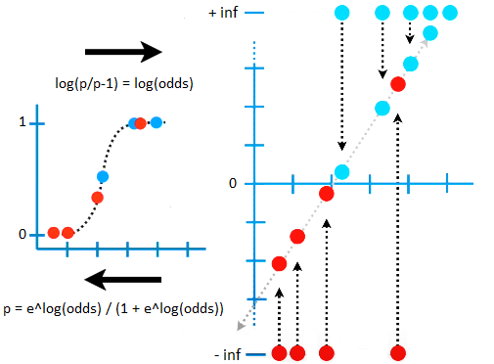
$$L given the squiggle=0,49×…×0,92×\left(1-0,9\right)×…×\left(1-0,01\right)$$
$$\log\left(L given the squiggle\right)=\begin{aligned}\log\left(0,49\right)+…+\log\left(0,92\right) \\ +\log\left(1-0,9\right)+…+\log\left(1-0,01\right)\end{aligned}$$
$$\max{\log\left(L given the squiggle\right)}→best fitting line$$
R-SQUARED
We know that the line is best fit … but how do we know if it is useful ?
In other words, how do we calculate R-squared and a p-value for the relationship between weight and obesity ?
The answer is … it´s complicated …
… even though pretty much everyone agrees on how to calculate R-squared and the associated p-value for linear models … there is no consensus on how to calculate R-squared for logistic regression … there are more than 10 different ways to do it !!!
So, before you settle on a way to calculate R-squared for logistic regression, look and see what other people are already doing in your field … that will give you a good starting point.
For this StatQuest, rather than describe every single R-squared for logistic regression, we´ll focus on one that is commonly used and can be easily calculated … this is McFadden´s pseudo R-squared …
This method is very similar to how R-squared is calculated for regular OLD LINEAR MODELS … so let´s do a super quick REVIEW of that:
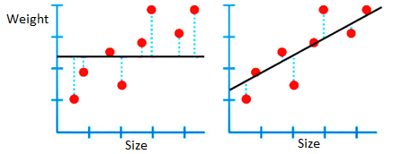
In linear models, R-squared and the related p-value are calculated using the residuals, we square the residuals and add them up (this is called SS(fit) for ´sum of squares around the fit´) … and we compare that to the sum of square residuals around the worst fitting line, the means of the y-axis values (this is called SS(mean)).
$$R^{2}=\frac{SS\left(mean\right)-SS\left(fit\right)}{SS\left(mean\right)}$$
$$0<R^{2}<1$$
So, R^2 compares the measure of a good fit SS(fit) to a measure of a bad fit SS(mean).
R^2 is the percentage of variation around the mean that goes away when you fit a line to the data.
If there isn´t a relationship between weight and size, then $R^{2}=0$ … on the other hand, when the line fits the data perfectly, then $R^{2}=1$.
Okey, now let´s talk about R^2 in terms of LOGISTIC REGRESSION … like in linear regression, we need to find a measure of a good fit to compare to a measure of a bad fit … unfortunately, the residuals are all infinite, so we can´t use them … but we can do the following:
First, we can project the data onto the best fitting line, and then we translate the log(odds) back to probabilities, and lastly calculate the log-likelihood of the data given the best fitting squiggle.
$$L:likelihood of the data$$
$$\log\left(L given the squiggle\right)=\begin{aligned}\log\left(0,49\right)+…+\log\left(0,92\right) \\ +\log\left(1-0,9\right)+…+\log\left(1-0,01\right)\end{aligned}=-3,77=LL(fit)$$
In this case that gives us -3,77 … we can call this LL(fit) for the log-likelihood of the fitted line and use it as a substitute for SS(fit).
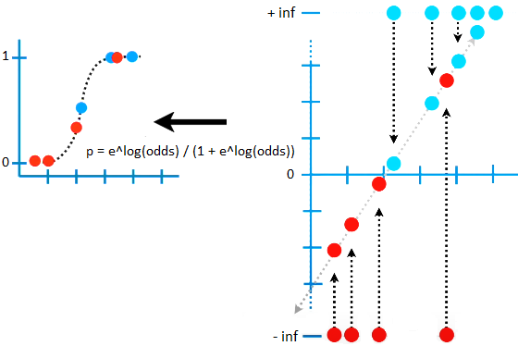
Second, we need a measure of a poorly fitted line that is analogous to SS(mean) … we do this by calculating the log(odds of obesity) without taking weight into account.
The overall odds of obesity is just the total number of obese mice divided by the total number of mice that are not obese , then we just take the log of the whole thing to have the log(odds of obesity).
$$odds of obesity=\frac{\# obese mice}{\# not obese mice}=\frac{5}{4}$$
$$\log\left(\frac{5}{4}\right)=0,22$$
So, in this case we get a horizontal line at 0,22 in the log(odds) scale, then we project the data into it, and then we translate the log(odds) back to probabilities … that gives us a horizontal line at $p=0,56$ .
NOTE: the overall log(odds) 0,22 translates to the overall probability of being obese 0,56. In other words, we can arrive at the same solution by calculating the overall probability of obesity.
$$p=\frac{\# obese mice}{\# total mice}=\frac{5}{9}=0,56$$
Finally, calculate the log-likelihood of the data given the overall probability of obesity:
$$\log\left(L given p\right)=\begin{aligned}\log\left(0,56\right)+…+\log\left(0,56\right) \\ +\log\left(1-0,56\right)+…+\log\left(1-0,56\right)\end{aligned}=-6,18=LL(overall prob)$$
We´ll call this LL(overall probability) and use it as a substitute for SS(mean).
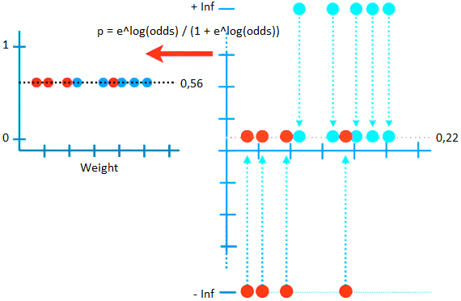
So, we have LL(overall) probability, a measure of a bad fit … and LL(fit), hopefully a measure of a good fit … and it makes intuitive sense that we could combine then, just like we combined SS(mean) and SS(fit), to calculate R^2…
$$R^{2}=\frac{LL\left(overall prob\right)-LL\left(fit\right)}{LL\left(overall prob\right)}=\frac{-6,18-\left(-3,77\right)}{-6,18}=0,39$$
Let´s verify that calculating R^2 with these log-likelihoods will result in a value near 0 when the fit is bad, and a value near 1 when the fit is good …
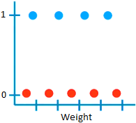
When weight is not a good predictor of obesity …
… LL(fit) = -6,18
… LL(overall probability) = -6,18
… then we´ll get an R^2 = 0

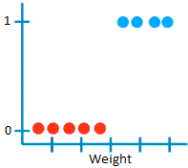
When weight is not a good predictor of obesity …
… LL(fit) = 0
… LL(overall probability) = -6,18
… then we´ll get an R^2 = 1

So, we see that, at least on an intuitive level, the R^2 calculated with the log-likelihoods behaves like the R^2 calculated from the sum of square residuals !
At this point, you may have noticed something … when the model is poor fit, the log-likelihood for logistic regression LL(fit) is a relatively large negative number … and when the model is a good fit, the LL(fit) is a value close to zero.
NOTE: LL for logistic regression will always be between 0 and -infinity because we are taking log values between 0 and 1.
P-VALUE
Okey, now we need a p-value … the good news is that calculating the p-value is pretty straight forward …
Two times the difference between LL(fit) and LL(overall probability) equals chi-squared value with degrees of freedom equal to the difference in the number of parameters in the two models:
$$2×\left(LL\left(fit\right)-LL\left(overall prob\right)\right) \sim Chi-squared$$
- LL(fit) has two parameters since it needs estimates for y-axis intercept and a slope.
- LL(overall probability) has one parameter since it only needs an estimate for a y-axis intercept.
So, in this case the degree of freedom equals 1.
Here is a graph of some chi-squared distributions for different degrees of freedom:
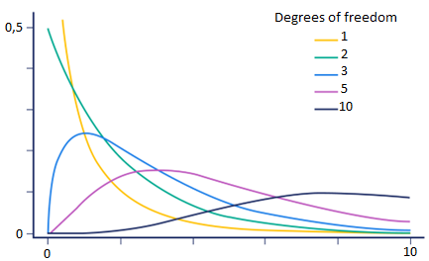
In the worst case scenario, LL(fit) = LL(overall probability) and the whole thing equals 0; in this case the p-value equals 1.
However, most of the time LL(fit) will be closer to 0 than LL(overall probability), and since the log-likelihoods are negative the whole thing ill be a positive number on the x-axis, and the p-value will get smaller.
In the example we were working on … we end up with 4,82 (a chi-squared value with 1 degree of freedom) …
$$2×\left(-3,77-\left(-6,18\right)\right)=4,82→p-value=0,03$$
… and the p-value equals 0,03, thus the relation between weight and obesity is not due to random chance, and R^2 value (0,39) tells us the EFFECT SIZE of this relationship.
SATURATED MODELS
Before we leave, there are a few things I need to point out …
When you see these formulas for R^2 and associated p-value put in the wild …
$$R^{2}=\frac{LL\left(overall prob\right)-LL\left(fit\right)}{LL\left(overall prob\right)}$$
$$2×\left(LL\left(fit\right)-LL\left(overall prob\right)\right) \sim Chi-squared$$
… they will look more like this:
$$R^{2}=\frac{LL\left(overall prob\right)-LL\left(fit\right)}{LL\left(overall prob\right)-LL\left(saturated model\right)}$$
$$2×\left[\begin{aligned}\left(LL\left(saturated model\right)-LL\left(fit\right)\right) \\ -\left(LL\left(saturated model\right)-LL\left(overall prob\right)\right)\end{aligned}\right]\sim Chi-squared$$
This is because the formulas usually include terms for the saturated model … we´ll talk about SATURATED MODELS in another StatQuest. For now, just know that when doing logistic regression, the log-likelihood of the saturated model equals 0, so we can omit it .
However, the log-likelihood od the saturated model isn´t always 0 when it is used for OTHER GLM (generalized linear models) …

